NAME : SUBODH YADAV AGE: 23 Y/ M DATE: 03 March 2026
Refd. By.: DR. SANJAY KUMAR MBBS
====================================================================
This Scan has been Proudly done on Brand New, Most Advanced 3 Tesla MRI

M.R.I. STUDY OF BRAIN

Technique:
MRI brain performed with standard sequences including T1, T2, FLAIR, DWI, GRE/SWI.

Findings:
Cerebral Parenchyma:
- Acute haemorrhagic contusions are seen in the left temporal lobe and left periventricular region.
- Surrounding oedema noted in these regions.
- SWI demonstrates multiple scattered microhaemorrhages diffusely distributed throughout the brain parenchyma, suggestive of traumatic diffuse axonal injury.
Ventricular System & Midline Structures:
- Ventricles are normal in size and configuration.
- No midline shift at present.
Extra-axial Spaces:
- No evidence of extra-axial haemorrhage (subdural/epidural).
- Basal cisterns are patent.
Posterior Fossa:
- Cerebellum and brainstem show no focal abnormality.

Other Structures:
- Orbits, paranasal sinuses, and mastoid air cells are unremarkable.
- Skull vault shows no obvious fracture on MRI.

Impression:
- Acute haemorrhagic contusions in the left temporal lobe and left periventricular region with surrounding oedema.
- Diffuse microhaemorrhages on SWI, consistent with diffuse axonal injury (DAI).
- Findings are in keeping with traumatic brain injury.

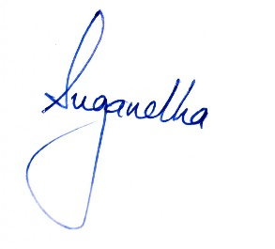
Suggested: Follow UP MRI BRAIN

